CMSC 430 7980 Project 2

I had a very hard time with this assignment. I felt like I was missing a fundamental piece of information, even though I had read through the texts and watched the videos countless times. I know my syntactical analyzer is not perfect, but I feel like I am getting nowhere and just bothering the Professor for constant revisioning.

My approach to this project was making the revisions from top to bottom, starting with [variables] and working my way down. Before that, I made sure to swap out the scanner.l, listings.cc and listing.h for the one I revised for Project 1. I also added the necessary tokens to parser.y. For lessons learned, I definitely learned a great deal about grammars and bottom-up parsing, as well as the role of recursion in Bison.

**Test Case 1: Arithmetic Operators**

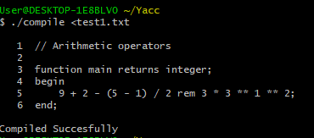

**Test Case 2: Relational and Logical Operators**

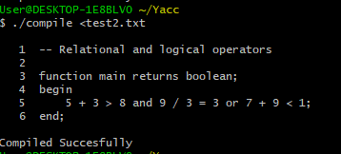

**Test Case 3: Conditional Expression**

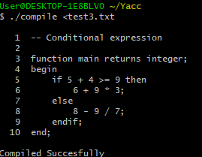

**Test Case 4: Variable Initialization**

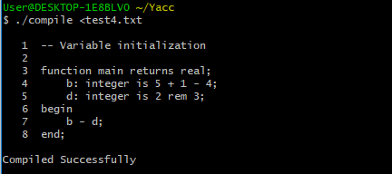

**Test Case 5: Parameter Initialization**

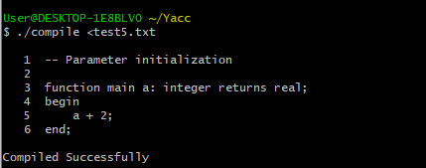

**Test Case 6: Parameter Initialization**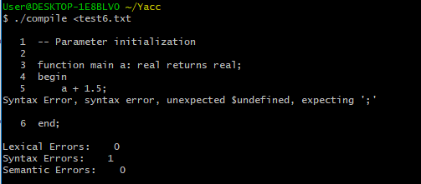

**Test Case 7: Test Case Statement**

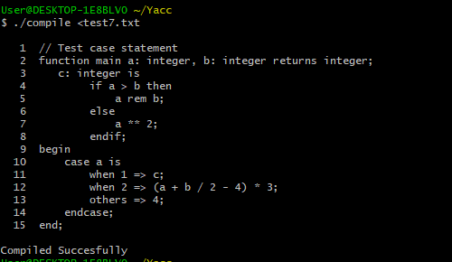

**Test Case 8: Function with a Reduction**

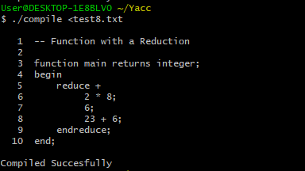

**Test 9: Test nested case**

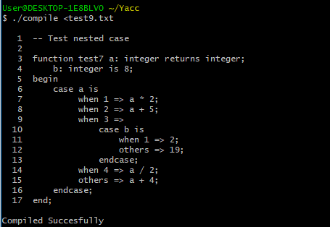

**Test 10: Two Parameter Initialization**

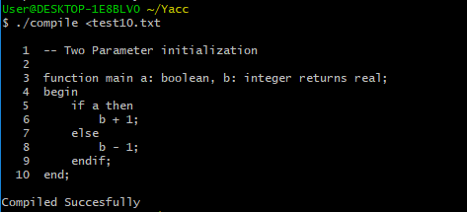

**Test 11: Function with a Reduction**

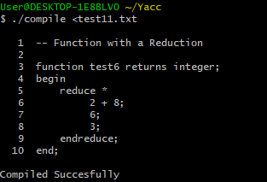

**Test 12: Function with a Nested Reduction**

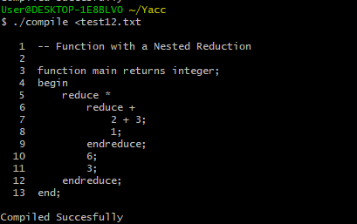

**Test 13: Multiple Error Input**

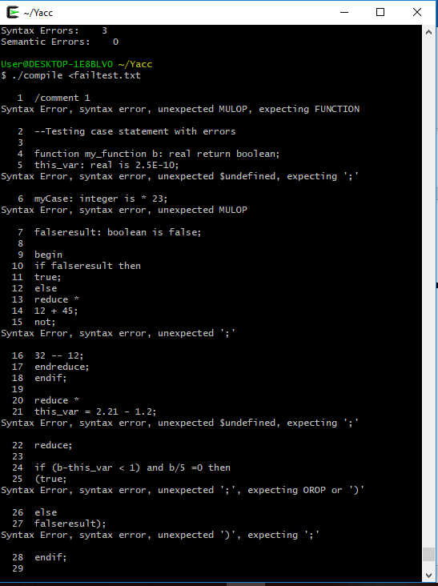 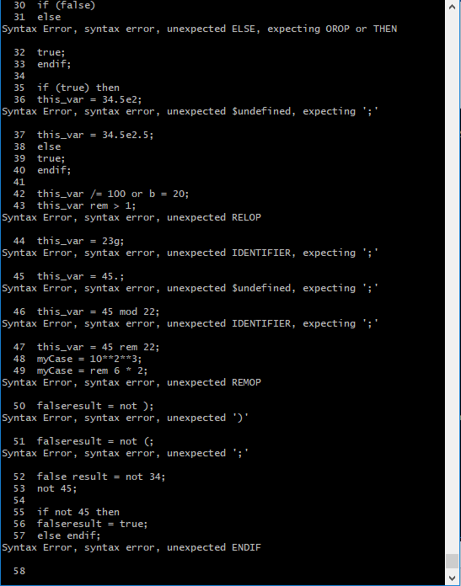

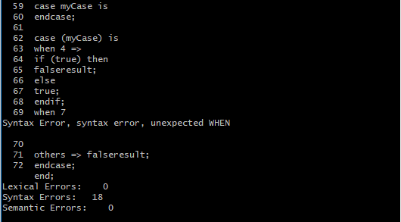

My only issue remaining with my syntactical analyzer is that I get a $undefined error concerning my variable and parameter definitions. I do not know why this is. I do not believe the error is in either my scanner.l or listing.cc file. Hopefully the Professor can reveal what the source of the error is and how it can be fixed once this assignment is submitted.

I know that I am submitting this assignment days after my extended deadline has passed, but I have been working tirelessly to get this project submitted and have hit speedbumps at every turn. There was the added issue of sending an email, waiting for a response, then fixing that issue only to run into another, and repeat… Initially I asked for the deadline because everyone in my family was sick, and I received an extra day to submit. Although I am appreciative of the extra time, it was hardly enough as my 3 children turned out to have the flu and were in need of constant attention. So juggling all of this was extremely difficult, especially because I, myself, was exhibiting the same symptoms as my children but there was no one to take care of me.

I am asking that 10 points not be deducted from my project grade because I really worked very hard each day, regardless of my home life, to get this assignment submitted.